0

JULY & AUGUST 2026

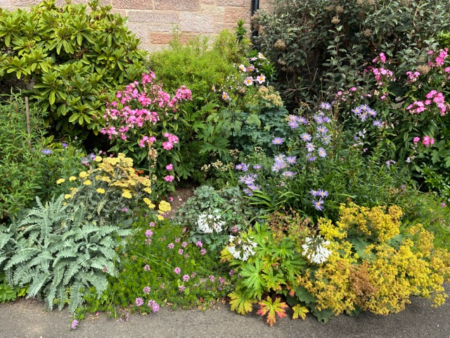

THE SIGN

ST. CUTHBERT’S

SCOTTISH EPISCOPAL CHURCH
COLINTON


THE SIGN
JULY & AUGUST 2026

St Cuthbert’s
Scottish Episcopal Church
Westgarth Avenue
Colinton
EDINBURGH
EH13 0BD

St Cuthbert’s is a welcoming, loving community, sharing God’s love through joyful worship and compassionate service.

If you wish to receive Home Communion, please contact Revd Nicki McNelly –
Tel: 0131 441 7580

 Facebook: @stcuthbertscolinton
 Instagram: stcuthbertscolinton

Front Page Photo – Summer in the hall floral border
Photograph: Louise Stobie

St Cuthbert's Scottish Episcopal Church Colinton


JULY & AUGUST 2026
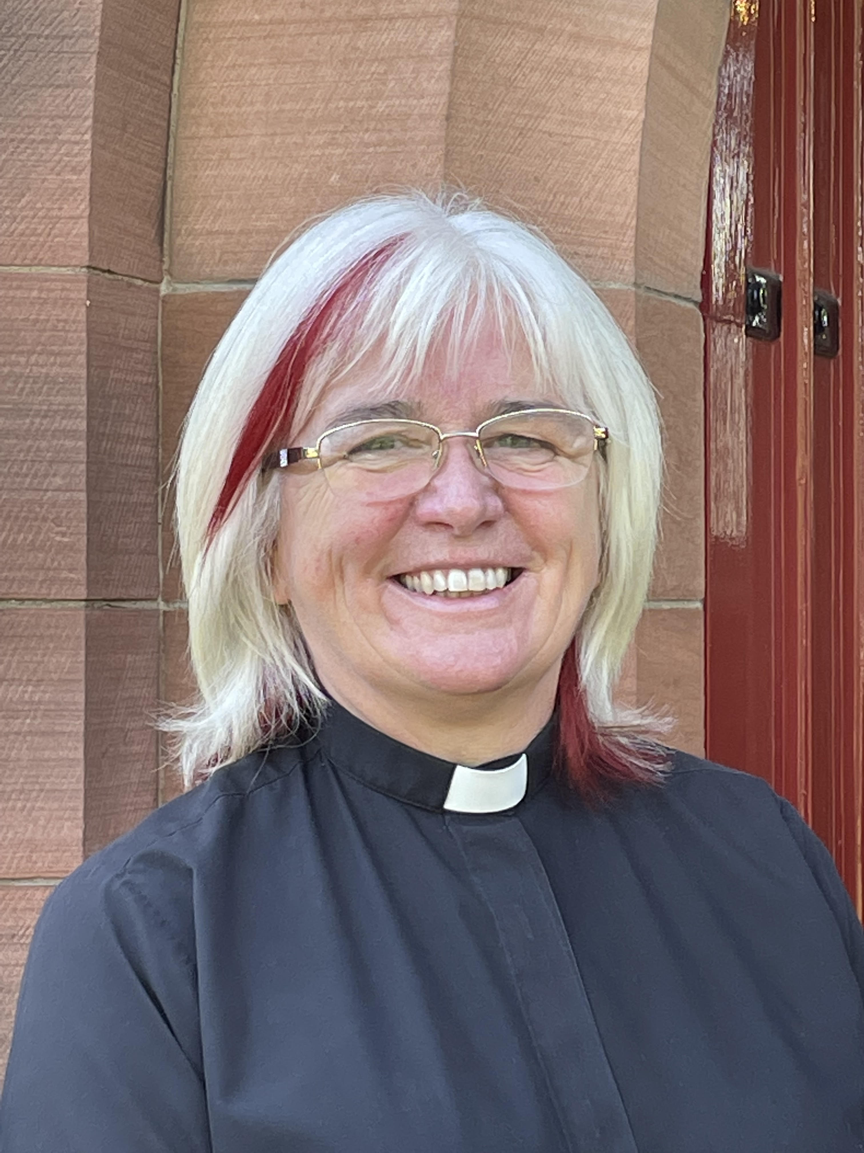

As we move into the summer months, there is much for which we can give thanks and much to look forward to in the life of our church community.
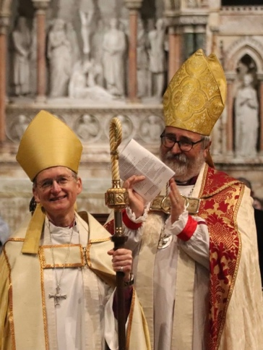
At the end of May, many of us were delighted to take part in the wonderful celebration for the installation of our new Bishop, Dagmar. It was a joyful and inspiring occasion, made even more special by the presence of bishops from our partner dioceses of Dunedin, Cape Coast and Espoo. We were particularly pleased that the Bishop of Espoo was able to visit our own congregation and share fellowship (and chocolate) with us. I hosted the Bishop of Cape Coast for the week and learnt much about his diocese.
Music always plays an important part in our worship, and on Music Sunday, we welcomed children from local schools who joined our choir and helped lead our singing. It was encouraging to see young voices and their enthusiasm enriching our worship and strengthening links with the wider community. The National Schools Singing Project is a wonderful project, and we are so lucky to have them using our church to practice. With thanks to the wonderful volunteers who help make this happen.
June brings a personal journey for me, as I travel to Poland to spend time with my daughter's family-in-law. I look forward to renewing friendships and enjoying this opportunity for family connections and hospitality.
Here at home, we are preparing for our Refugee BBQ, which promises to be a happy occasion bringing people together in friendship and welcome, including our Ukrainian friends and members of New Scots. During the event, we will also be installing our Peace Pole, a visible reminder of our commitment to peace and understanding among all people.
Particular thanks go to the members of Pentland Men's Shed, who have created an indoor "graffiti" Peace Pole. This imaginative project will allow everyone to add their own words and messages of peace, making it a living expression of our hopes and prayers for the world.
On August 22nd we will be hosting a newcomers afternoon tea. If you have joined or rejoined us in the last two years, you will be very welcome. Please let me know if you plan to attend for catering purposes.
A reminder that we will celebrate Harvest a week earlier this year as Bishop Dagmar will join us on September 27th.
As summer unfolds, may we continue to cherish the blessings we share, welcome one another with generosity and kindness, and seek always to be instruments of Christ's peace.
With every blessing
Nicki





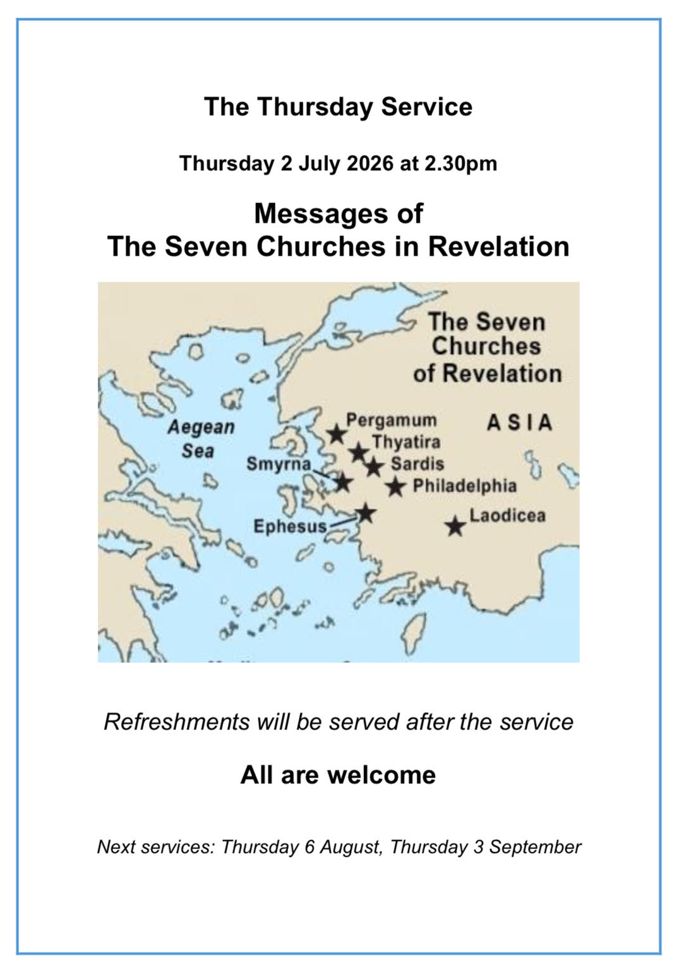

Reflections for July and August from Revd. Margaret
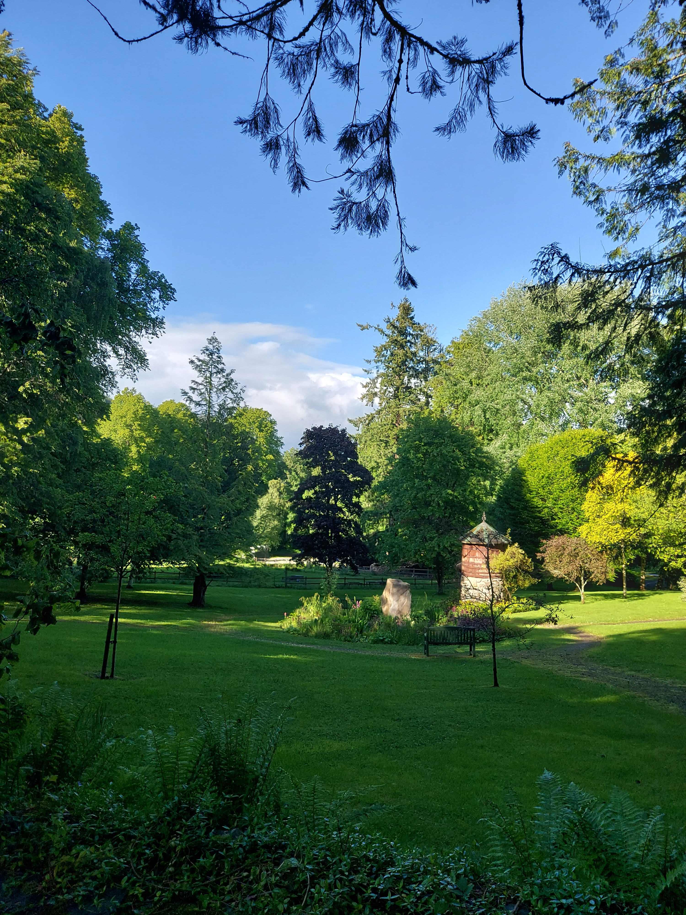

As I write this, in the first week of June, I am wondering if summer rushed past us last week, casting a brief and glorious glow over my house removal, before heading off somewhere else! Nonetheless, as we progress towards the high summer months of July and August, the long hours of daylight, accompanied by beautiful birdsong, remind us that the season we know as summer is truly with us, no matter what the weather, no matter what the temperature.

Alongside seasonal celebrations at church, there are festivals and events close at hand in our city, and glorious floral displays to be enjoyed everywhere, from balcony to garden, from park to field, accompanied by the heavy, verdant foliage of innumerable trees. And what better area in which to benefit from this than our own, former village of Colinton.

I found this wonderful little quote about summertime in the work of a nineteenth century spiritual nature writer, Richard Jefferies: ‘It is enough to lie on the sward in the shadow of green boughs, to listen to the songs of summer, to drink in the sunlight, the air, the flowers, the sky, the beauty of all. Or upon the hilltops to watch the white clouds rising over the curved hill-lines, their shadows descending the slope…in-drawing the life of the earth and the sun.’ I hear in those words a call from God to appreciate the beauty of his created world, especially at this time of year, but I would advise that, given the age profile of our congregation, the enjoyment should be experienced from a garden seat or a wooden bench!

Holidays – when you read this, I will have been cruising round the stunning coastlines of Scotland and Ireland, followed by a short foray around the fjords of one of my favourite countries, Norway. Hopefully, many of you will be experiencing happy times with spouses, family or friends, either travelling abroad or within the UK, or relishing short days out from home.

Please join us for our upcoming monthly Thursday afternoon services. On the 2nd July Joan will be intriguing us with ‘Messages of The Seven Churches in Revelation.’ Then on 6th August Caroline will present the heartening subject of ‘The Humanity of the Disciples.’ On the 3rd September, as summer draws to a close, I will tackle a theme appropriate to the Creationtide we so meaningfully celebrate that month. After every one of these service, refreshments and fellowship afterwards form an important part of the afternoon.

In the meantime, my love and blessings to you all, as you enjoy the ups and downs of a Scottish summer: and for those going through difficult times, remember those heartwarming words in the poem ‘Footprints in the Sand’: ‘The times when you have seen only one set of footprints, my child, is when I carried you.’


Margaret, NSM.

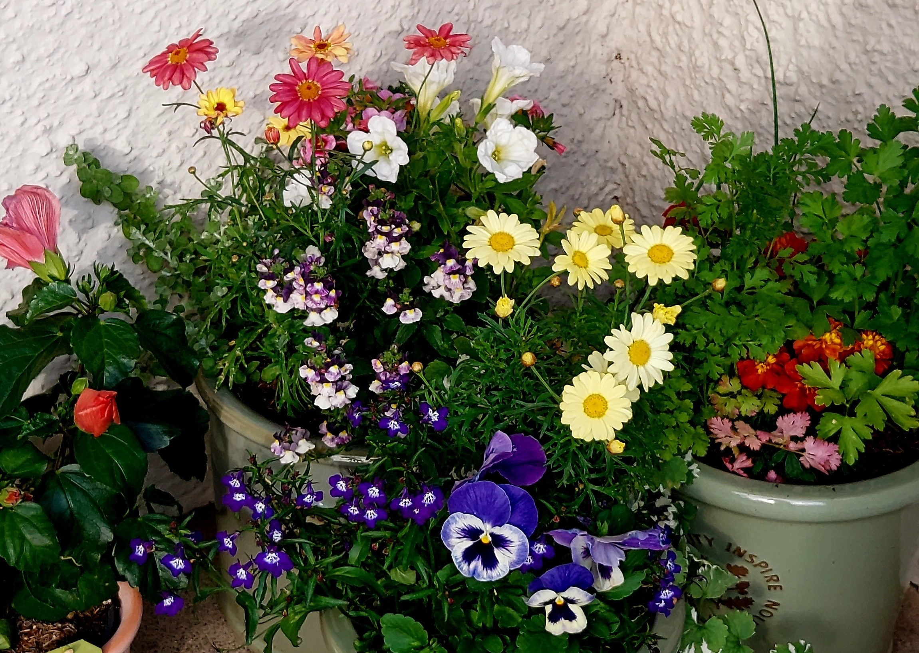

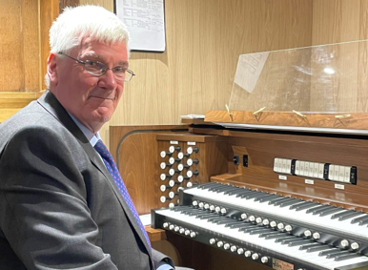
MUSIC ARTICLE FOR
JULY & AUGUST 2026

In this edition of The Sign, I would like to record my sincere thanks to
Michael Green and Andrew Matheson, who have played the organ at
St Cuthbert’s on one Sunday per month each for the past fifteen months. It has certainly made a huge difference to me to reduce my commitment, giving me more time to look ahead and to practise voluntaries, without the need to be doing so every week. Michael has made the decision to stand down from his commitment because of changing circumstances, and plays for us for the last time on 12 July when I am on holiday in France. We thank him for his involvement, and are pleased that he is willing to be asked for one-off services in the future if the need arises. Our thanks also go to Andrew, who will play at St Cuthbert’s on a less regular basis in the future. We will continue to see him as a member of the choir, when he is not needed to play elsewhere, and on occasion at our organ. After a break in July and August for a family holiday, he will play for the last of his “regular” services on Sunday 20 September, again when I am away on holiday.

I am pleased to announce that we will be welcoming
Iain Mackinnon to play the organ on two Sundays per month from August onwards. Iain has played for a service at St Cuthbert’s quite a number of years ago, and has most recently shared the post of organist and choirmaster at the Church of the Good Shepherd. His first service with us will be on 16 August, but he will attend the service on 26 July, sitting with the choir and getting to know the format of our service. We very much look forward to welcoming him to St Cuthbert’s. I will continue to play on two Sundays per month, special services, evensongs, and to take choir practices and select the hymns and anthems.

Our provisional anthem list, dependent on numbers, for July and August is detailed below.

5 July: Lead me, Lord - SS Wesley
12 July: Incline thine ear - F Himmel
19 July: Teach me, O Lord - T Attwood
26 July: Jesu, joy of man’s desiring - JS Bach
26 July, Evensong: Day by day - N Warren
2 August: Oculi omnium - C Wood
9 August: Peace I leave with you - FW Wadely
16 August: Ave verum corpus - WA Mozart
23 August: Adoremus te, Christe - T Dubois
30 August: God so loved the world - J Stainer

Philip Rossiter

St Cuthbert’s, Colinton
Evensong Service
26th July
30th August
@ 5pm
All Welcome

GENERAL SYNOD 2026
STIRLING UNIVERSITY

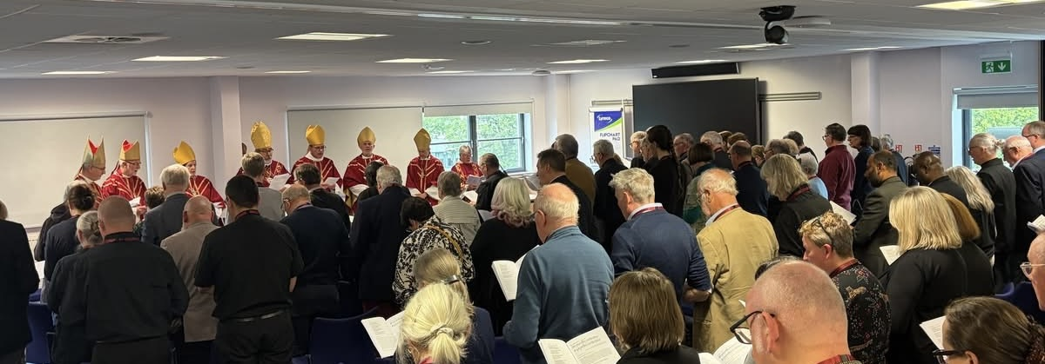

From 11th–13th June, I had the privilege of attending General Synod at the University of Stirling, a beautiful setting where we were constantly reminded of the wonder and beauty of God’s creation surrounding us.
This was the first time I have attended a residential Synod, with members living, worshipping and meeting together in one place throughout our time together. Although change can often bring challenges, this proved to be one of the most enriching and encouraging Synods I have experienced. Whether it was the inspiring worship, the important matters discussed, the spirit in which business was conducted, or the enthusiasm and dedication of those leading each session, there was a real sense of fellowship and shared purpose.
The General Synod Office deserves particular thanks. Having recently relocated and launched a new website, they nevertheless organised and delivered the Synod with remarkable professionalism and grace. Their hard work and commitment were evident throughout and are worthy of our gratitude.
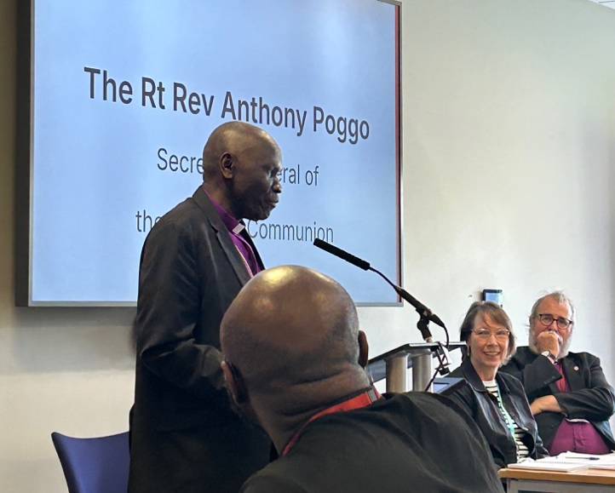
I was pleased to host our guest from the Church of Scotland, the Revd Ross Blackman, Convenor of their Ecumenical Relations Committee, and we were especially blessed to welcome the Rt Revd Anthony Poggo, Secretary General of the Anglican Communion, who shared in the life and worship of the Synod for its entirety. His presence served as a reminder of our place within the wider Anglican family and of our calling to walk together in faith and communion with Christians across the world.
Above all, it was a joy to gather with brothers and sisters in Christ, united in prayer, worship and service, seeking God’s guidance as we discern the work to which He calls His Church.
Revd Nicki

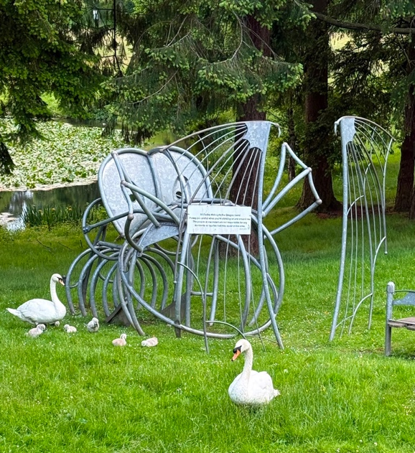
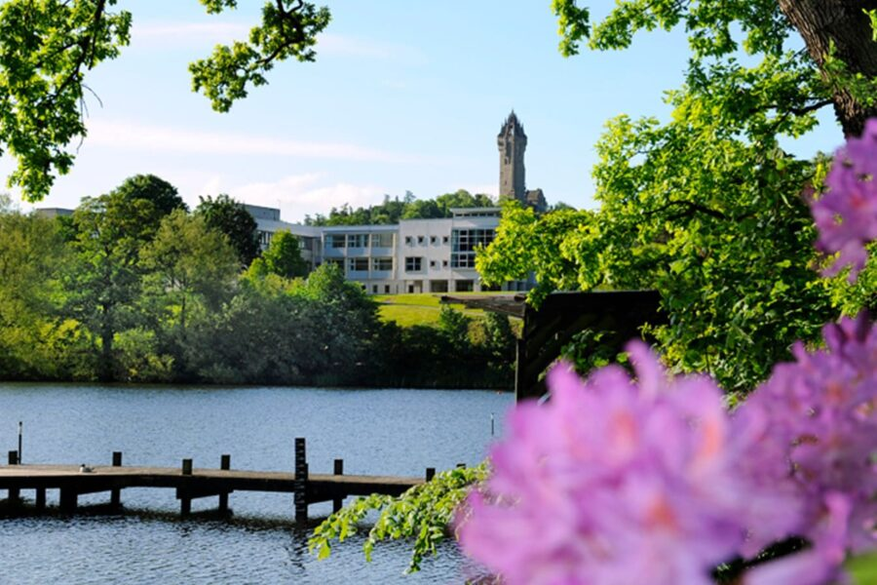



JULY 2026
ROTAS

AUGUST 2026 ROTAS

JULY 2026 READINGS
Taken from NRSV



5th July – Pentecost 6

Zechariah 9. 9-12
Romans 7. 15-25a
Matthew 11. 16-19, 25-30

12th July – Pentecost 7

Isaiah 55. 10-13
Romans 8. 1-11
Matthew 13. 1-9, 18-23

19th July – Pentecost 8

Isaiah 44. 6-8
Romans 8. 12-25
Matthew 13. 24-30, 36-43

26th July – Pentecost 9

1 Kings 3. 5-12
Romans 8. 26-39
Matthew 13. 31-33, 44-52

AUGUST 2026 READINGS
Taken from NRSV

2nd August – Pentecost 10

Isaiah 55. 1-5
Romans 9. 1-5
Matthew 14. 13-21

9th August – Pentecost 11

1 Kings 19. 9-18
Romans 10. 5-15
Matthew 14. 22-33

16th August – Pentecost 12

Isaiah 56. 1, 6-8
Romans 11. 1-2a, 29-32
Matthew 15. 21-28

23rd August – Pentecost 13

Isaiah 51. 1-6
Romans 12. 1-8
Matthew 16. 13-20

30th August – Pentecost 14

Jeremiah 15. 15-21
Romans 12. 9-21
Matthew 16. 21-28

6th September – Creation 1 (Pentecost 15)

Ezekiel 33. 7-11
Romans 13. 8-14
Matthew 18. 15-20

THE SIGN MAGAZINE

Please note –
The deadline
for information and articles
for the

SEPTEMBER 2026 issue

is
Sunday 16th August 2026

Please send to stcuthbertscolinton@gmail.com

Thank you!



At St. Cuthbert’s,
Westgarth Avenue, Colinton

Monday 6th July
Monday 20th July
~
Monday 3rd August
Monday 17th August

2pm – 4pm

Join us for an hour of music and memories.
Bring a friend or come and meet new ones.
Followed by refreshments.

forgetmenotes.org.uk
stcuthbertscolinton.org.uk

For more information, contact stcuthbertscolinton@gmail.com

All Welcome


St Cuthbert’s Playgroup in the Church Hall

We are now on summer holiday! Our restart date is
Monday 24th August

10am – 11.30am –
Every Monday
(during school term time)

Play, craft, snack and sing
Only £2 per family



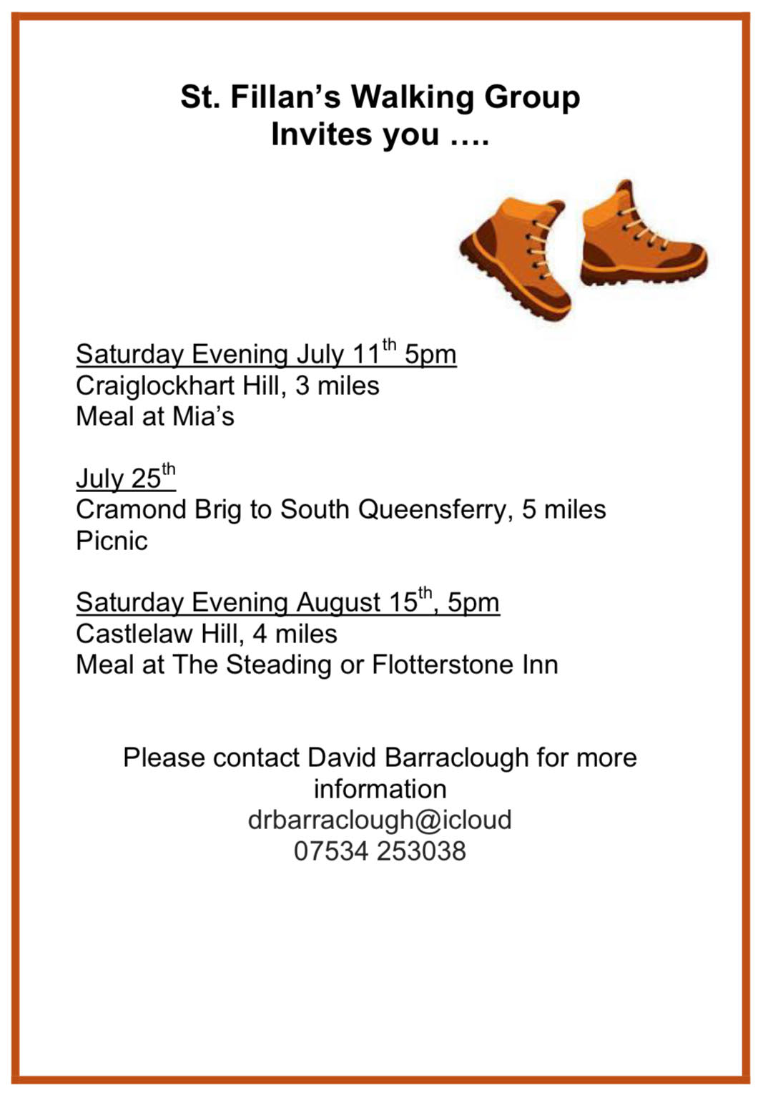

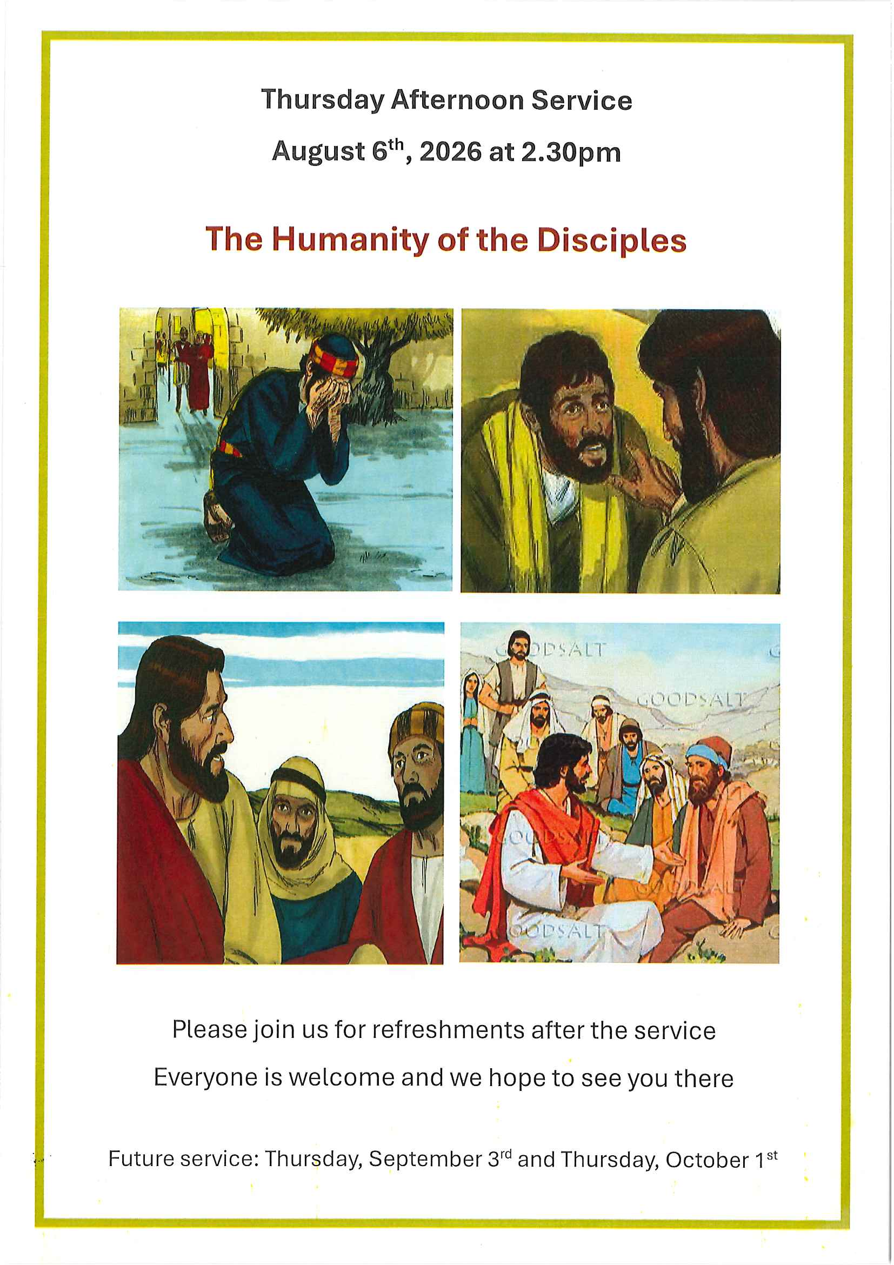

THE LEPROSY MISSION

GREAT BRITAIN

We have Steven McLeish, TLM’s Scottish representative coming to speak to us at the 10.30 service on July 19. There should be a chance to chat and ask questions afterwards, and also to donate.
Steven is a preacher, speaker, writer and a BBC contributor. Through his passion for the spoken word, he raises the voices of people needing to be heard. He quotes an African proverb ‘alone you go faster, together you go further’ .. “God is using people in ‘ordinary’ churches to join together to do the extraordinary.”
From New Day, May 2025

News … Anandaban Hospital, high above Kathmandu, Nepal, has served people affected by leprosy for nearly 70 years. Rocked by wildfire and a devastating landslide in 2024, the hospital continues amidst the aftermath of these challenges. Home of world-leading leprosy research it also caters to the general public in its outpatient department and renowned dermatology and orthopaedic services.
The planned new research building was cancelled following expert advice after the landslide. However the very good news is that the land has now been purchased in Kathmandu!
Current Appeal .. The Leprosy Mission’s Home of Love at Bankura, rural West Bengal.
Bankura is an oasis of care for elderly and disabled people affected by leprosy. Sustained by your kindness, it’s a place of welcome, healing, and peace.
It’s this welcome, healing, and peace that we find in Jesus. Scripture is full of rich reminders that God will give us a home. Not just a physical space to rest, but a place to belong in Him. It’s a beautiful blessing – one we are all invited to share in, and share with others.
For elderly people with leprosy in India, life can be unimaginably hard. Many have faced decades of heartbreaking rejection. Without social support, others must rely on begging just to survive.
- Please pray that the Lord will meet their daily needs and more. Ask that He will bless them, and pour His provision on them.
- Pray too that Jesus will sustain and comfort elderly people with leprosy when they feel alone. May they know that they are seen and loved
Prayers
For wisdom for Anandaban’s leadership team and architects as they plan the next phase of the work on the new research centre at Anandaban.
For the support and resources needed at Bankura to sustain this home of love and care.
Kay Dalley

SINGING in the SUMMER / OPEN REHEARSALS on the 7th and 14th SEPTEMBER

Our 8 Singing in the Summer evenings here at St Cuthbert’s went very well and the choir was very grateful for the use of the church for these popular sessions, when we sing a variety of pieces just for pleasure and without having a concert.

Please join us for either or both of our Open Rehearsals on Monday the 7th and 14th of September in the Memorial Hall, at Merchiston Castle School, Colinton Road. Our Open Rehearsals provide an opportunity to find out more about our choir and see what it would be like to sing with us but with no commitment to join.

We are a very welcoming, non-auditioning choir with a mixed range of ages and singing and sight-reading abilities. We will be learning "THE FIRST NOWELL" by Vaughan Williams, "IN TERRA PAX" by Finzi, "GAUDETE" and selection of CHRISTMAS CAROLS with audience participation, for our Christmas Concert on 7th DECEMBER.

We rehearse on Monday evenings in the Memorial Hall from 7th September onwards. After the Open Rehearsals, our rehearsals will begin at 7.15 pm and end at 9 pm but it’s not a problem if you can’t be there for 7.15 pm or have to leave early.

We have great fun but also learn a lot with our enthusiastic and dynamic Director of Music, Tim Coleman, and our Accompanist, the excellent and well known Morley Whitehead.

For more information about our choir, please consult our website www.colintonchoir.org or our Facebook page

Margaret Kieran on behalf of the Choir

(Please see noticeboards for further details or speak to wendy pearson)
WHo’s Who at St Cuthbert’s

Rector The Revd Nicki McNelly
stcuthbertsrector@gmail.com
Tel: 0131 441 7580

NSM (Non-Stipendiary Revd Dr Margaret McCrindle
Minister) stcuthbertsnsm@gmail.com (07931 483906)

Church Administrator Marie Neil stcuthbertscolinton@gmail.com
Tel No: 07761 056504 Working hours:
Monday, Tuesday, Wednesday 9am-1pm
Rector’s Warden Judith Mackintosh 443 1313
People’s Warden George Bungay 478 0834
Children/Young People Contact Revd Nicki McNelly
Gift Aid Contact Church Administrator
Lay Representative Andrew Daye
Alternate Lay Rep. Jean Wood
Safeguarding Christine Nimmo 445 3053 christinenimmo@btinternet.com
Organist & Choirmaster Philip Rossiter 283 0234
Property Committee Nicki McNelly
Sacristans Bev Henderson, Joan Smith
Treasurer & Heather Tidy
Book-Keeper stcuthbertstreasurer24@gmail.com
Vestry Secretary Julia Roberts 441 4965
Julia.roberts01@btinternet.com
Website &
Magazine Editor Church Administrator stcuthbertscolinton@gmail.com
Archivist Christine Nimmo
R&R Wendy Pearson wendypearson37@gmail.com
Badminton Club Julia Roberts 441 4965
Coffee Rota Audrey Naden 441 1545
Eco congregation Kay Dalley 441 7920
Hall Bookings Contact our Church Administrator
Events & Fundraising Email:stcuthbertsevents@gmail.com
Leprosy Mission Kay Dalley
Fresh Start Wendy Pearson wendypearson37@gmail.com
Phoenix Group Margaret Kieran 445 3751
St. Raphael’s Rep. Judith Mackintosh 443 1313
Vestry Members * George Bungay, Jayne Churchill, Bryan Dale,
Kay Dalley, Andrew Daye, Megan Emmerson, Mandy Johnston, Judith Mackintosh, Ian Miller,
Julia Roberts, Christine Sanderson,
Esther Srinivasulu

When I am afraid, I put my trust in you. Psalm 56.3

St Cuthbert’s

Scottish Episcopal Church

Westgarth Avenue, Colinton, Edinburgh EH13 0BD

Tel: 0131 441 7580
Email: stcuthbertsrector@gmail.com

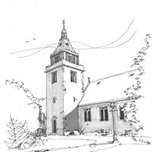

www.stcuthbertscolinton.org.uk

Services:

Wednesday:
10.30am Said Eucharist

First Thursday of each month:
2.30pm An informal service for all

Last Tuesday of each month:
12 noon Prayers for Peace

Sunday:
8.30am Said Eucharist, no sermon
10.30am Sung Eucharist

Evensong – ‘announced’ in our pew notices and
on our Website.

Scottish Charity Number: SC007578


